**Day 3 - AWS - EBS ,Snapshot (28/06/2024)**

**Elastic file system (efs):**

* **elastic file system is one of your storage service in aws.**
* **you can access this Efs with multiple aws resources simultaneously. So you can connect this Effs with multiple Ec 2 missions.**
* **In EBS scaling not possible .in EFS scaling possible.**
* **Scaling means we can increase or decrease memory size /vol size.**
* **if this supports the network file system version 4, that is nfs version 4.1 and Nfs version 4.0 protocol.nfs – protocol.**
* **how do you create this protocol for Ec, 2. Mission to access your Ec 2. Mission? We need Ssh protocol. So you open up the port Number 22**
* **wherein for accessing your Effs volume ,they are saying that you need a network file system protocol, which means Nfs pro protocol has to be open.**
* **So you create a security group before you create before you launch. Efs, you create a security group with your Nfs protocol and you attach this security group to your Efs volume.**

**Create security group for ec2:**

1. **One for security group for ec2 (ec2securitygroup)**
2. **Another security group for efs (efs securitygroup)**

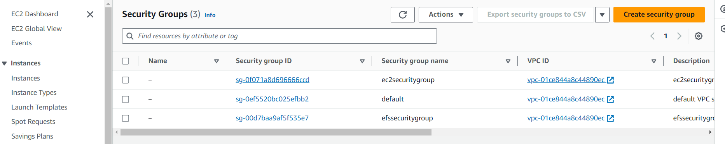

**Yasmine o/p screen**

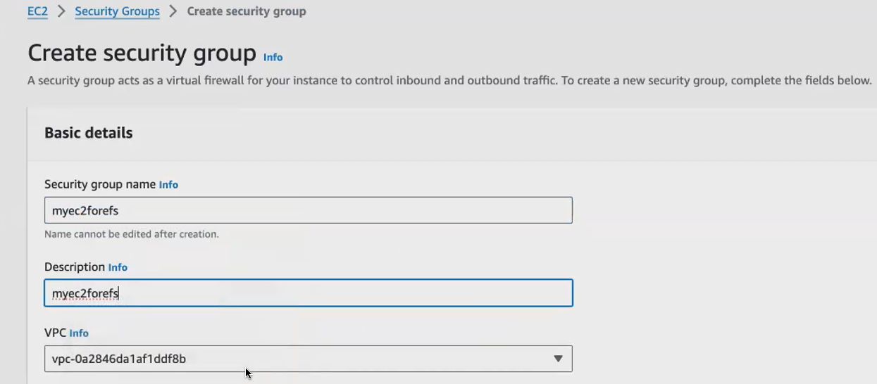

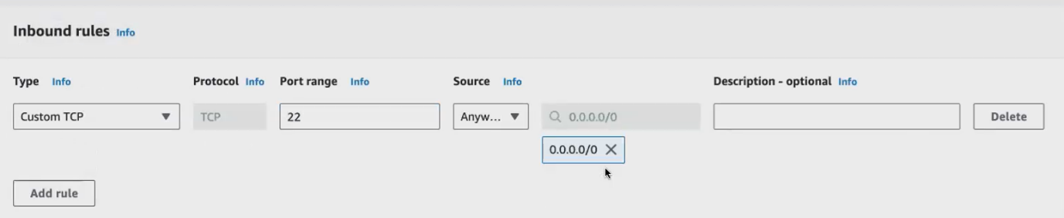

**Click create security group**

1. **Another security group for efs**

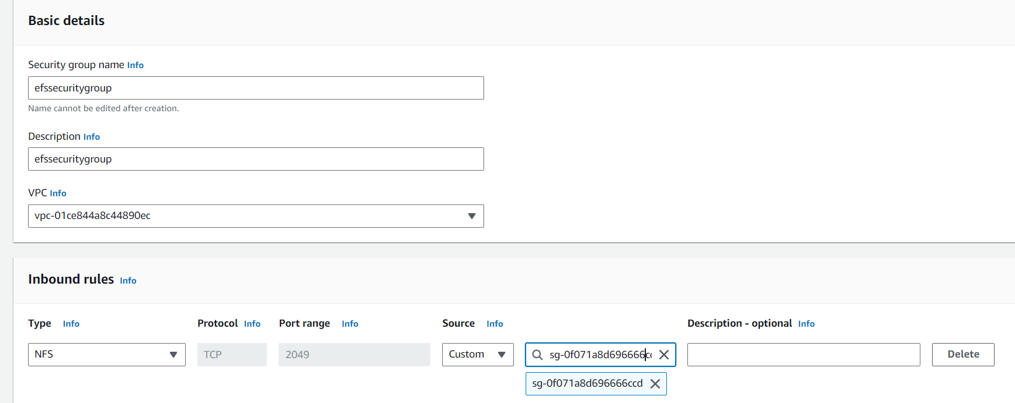

**Efs run in NFS protocol .click myec2forfs (s.g name for ec2)**



**To launch new instance:**

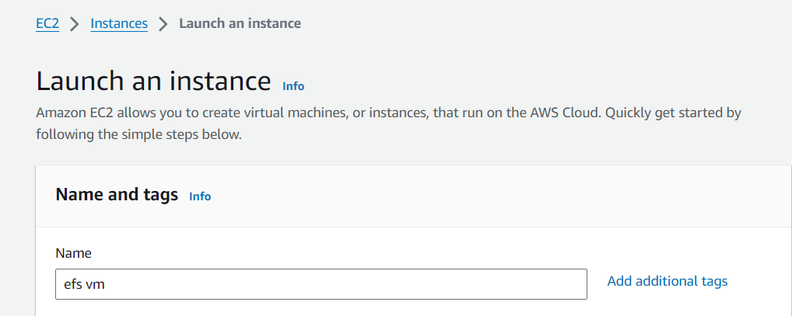

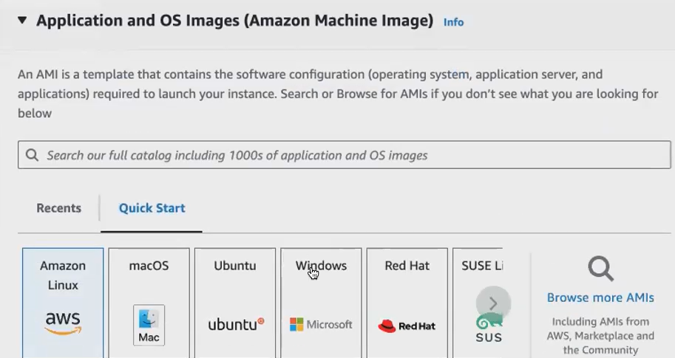

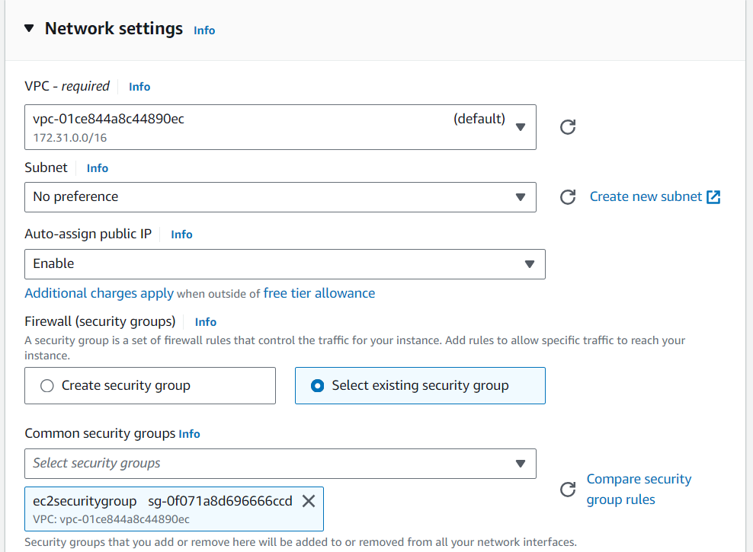

**Click launch instance**

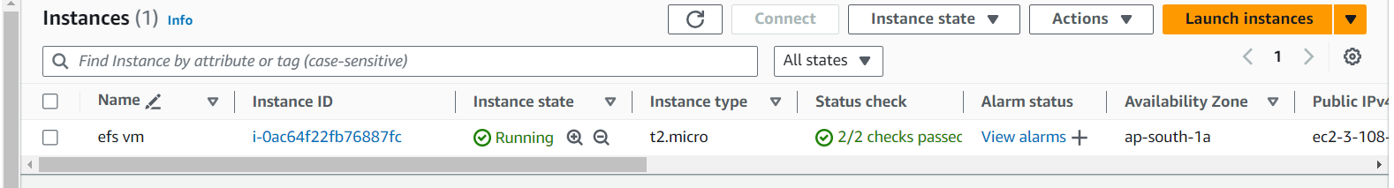

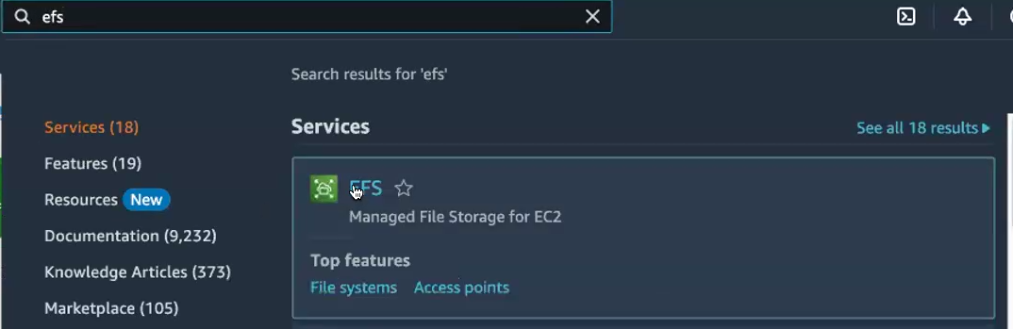

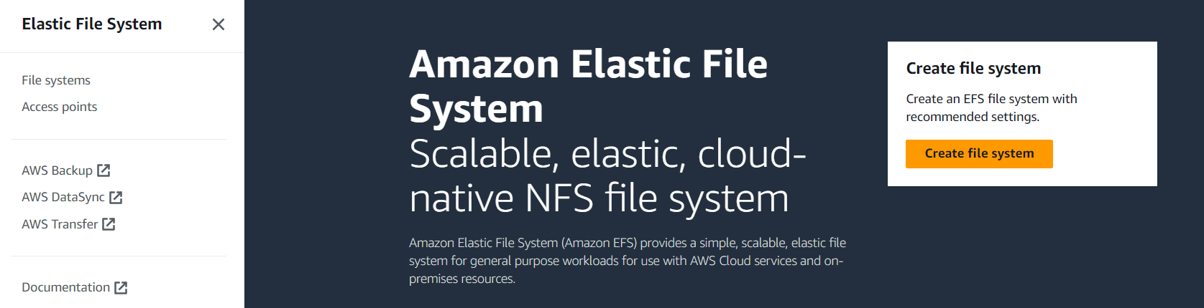

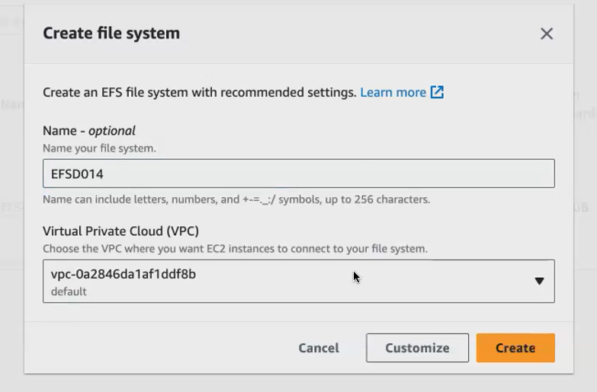

**Click customize ,below settings available .total 4 steps**

**Step 1:**

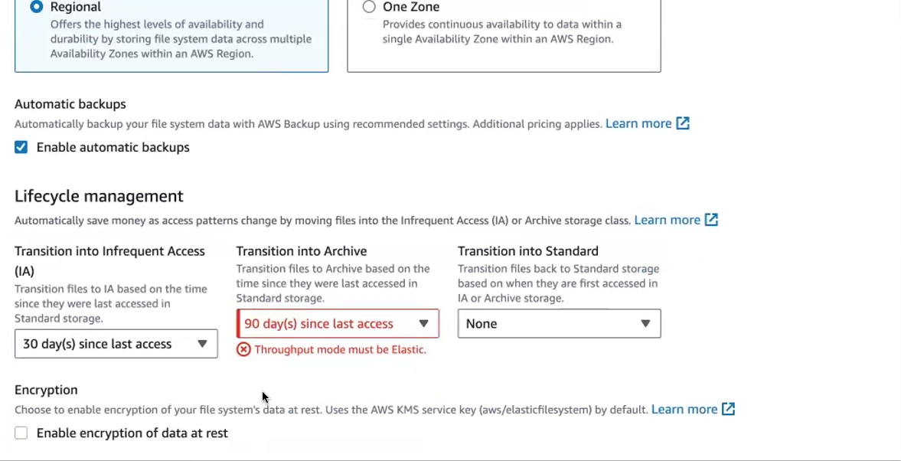

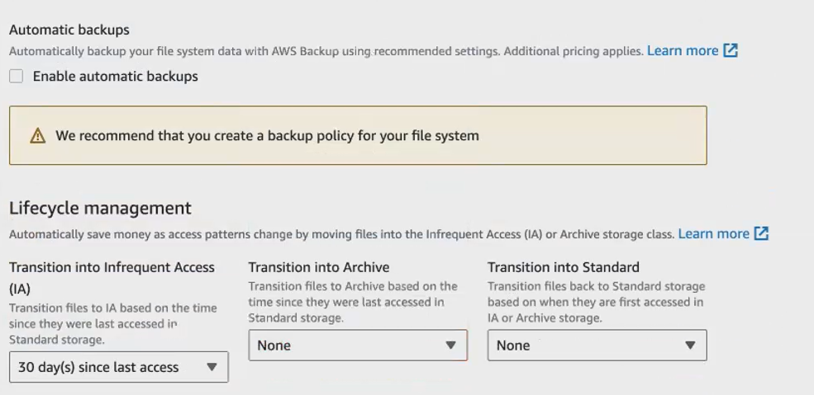

**Bursting is free so we select this**

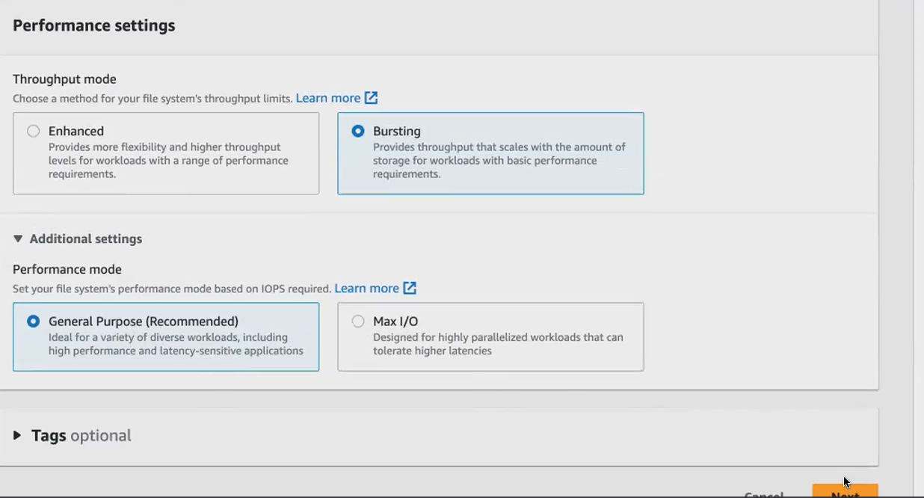

**Step 2:**

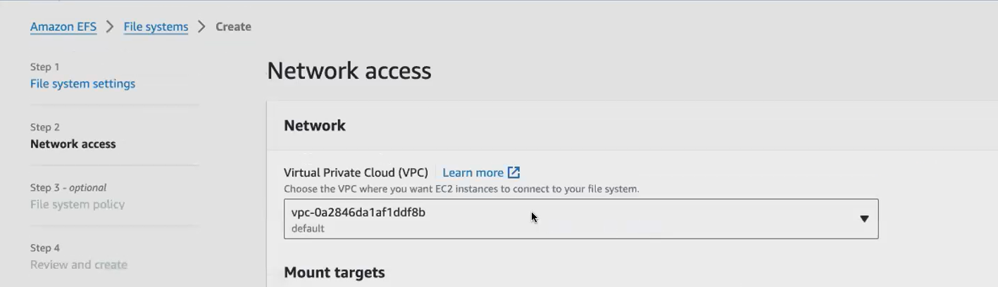

**Delete all default security group add our created security group. Click next**

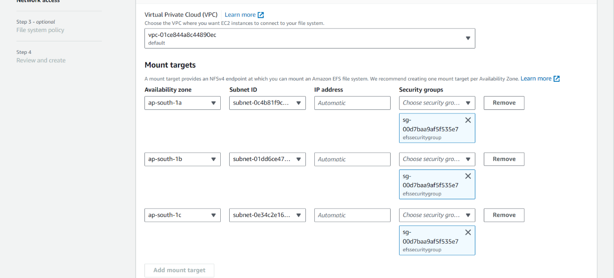

**Step 3:**

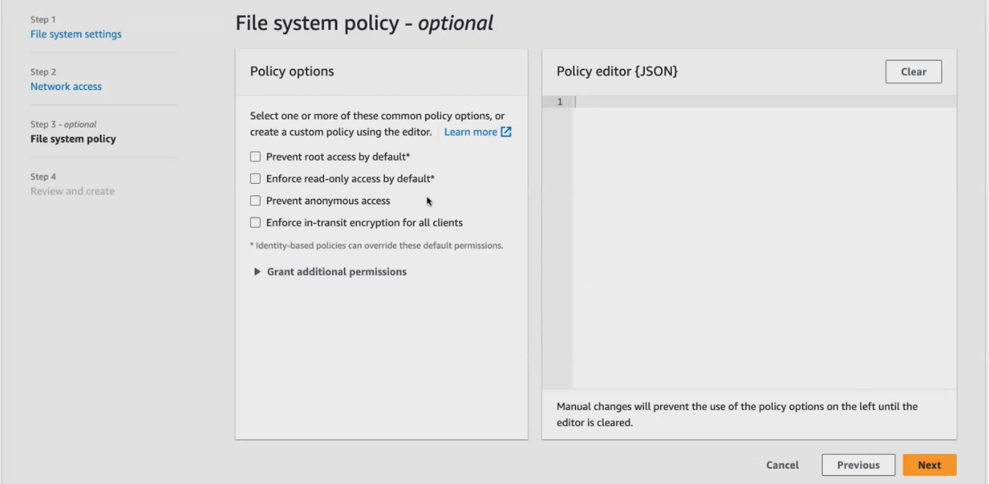

**Step 4:**

**No change ..click create f.s.file system created**

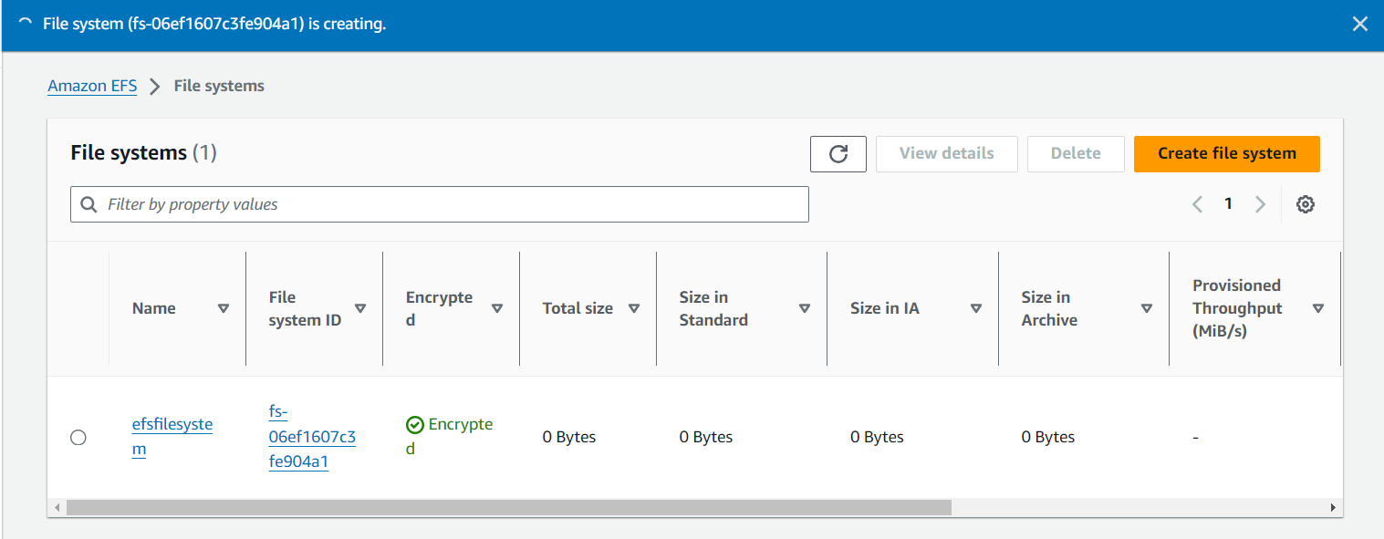

**Now f.s created .how to attach this with ec2. 1st create access point**

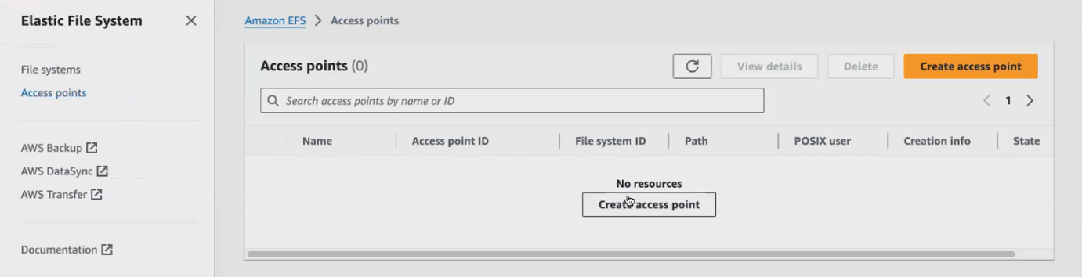

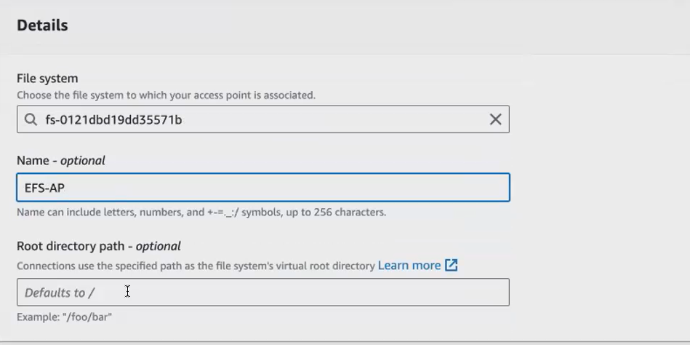

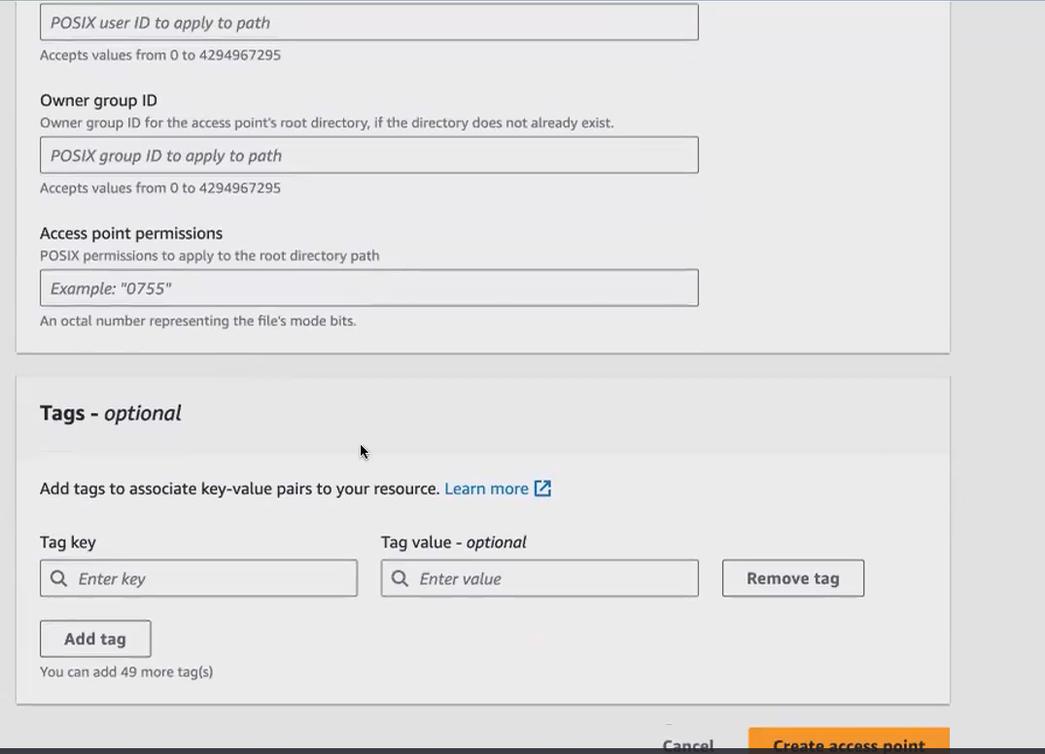 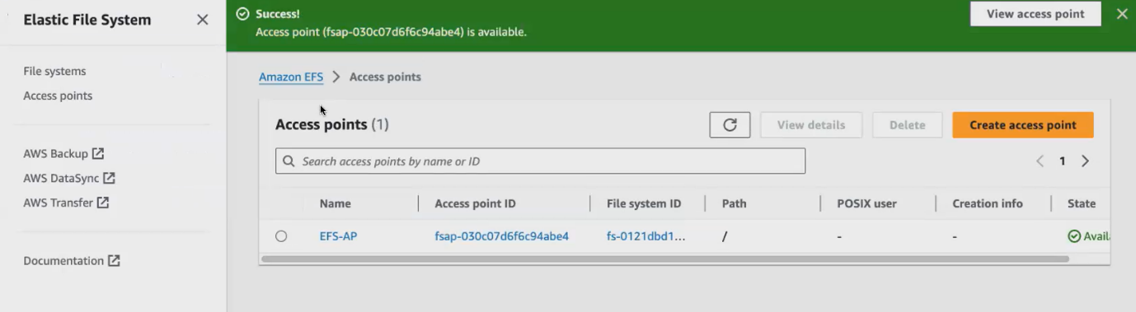

**Access point created .then go to ec2 attach that efs.click ec2 🡪connect that ec2**

**This is amazon linux**

[**https://docs.aws.amazon.com/efs/latest/ug/installing-amazon-efs-utils.html**](https://docs.aws.amazon.com/efs/latest/ug/installing-amazon-efs-utils.html)

**installation step for efs**

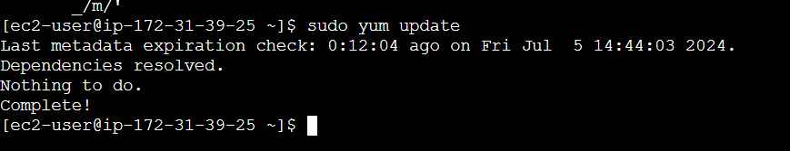

**That cmd copy from installation docu.link is above**

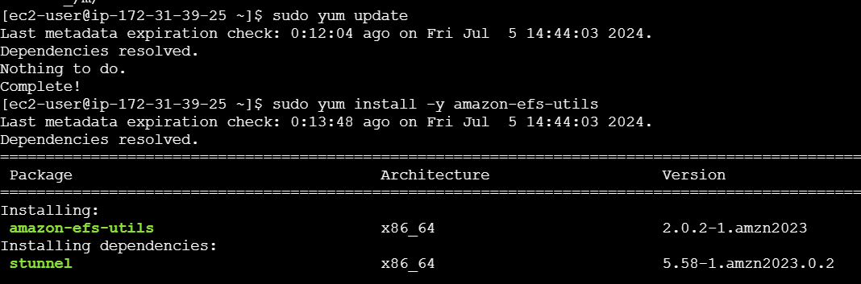

**Efs connected with ec2 via access point**

1. **Create mount point then attach it to efs volume**
2. **Copy that cmd in vi editor**

[**https://docs.aws.amazon.com/efs/latest/ug/automount-with-efs-mount-helper.html**](https://docs.aws.amazon.com/efs/latest/ug/automount-with-efs-mount-helper.html)

**below cmd available in that link**

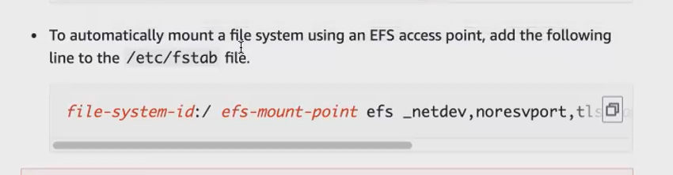

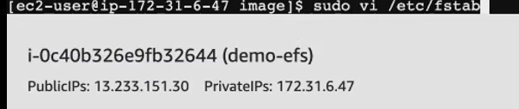

**Get file system id and access point that we created .give init.give mountpoint also**

1. **file system id**





**Search efs 🡪 getinto that 🡪 already created file system🡪file system id available .copy and paste it in vi editor**

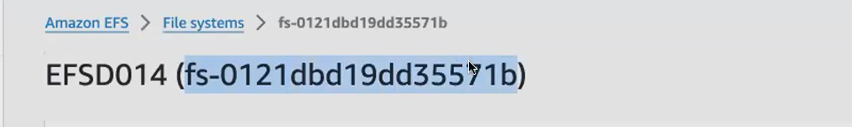

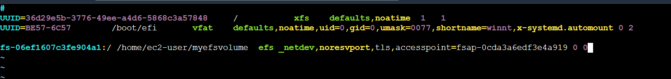

1. **access point id:**

**click create access point .give name and all**

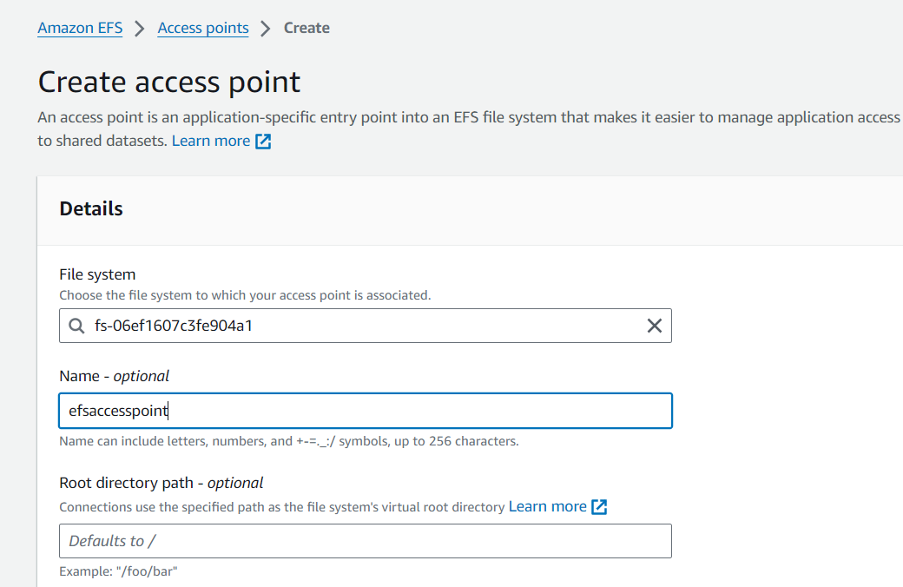

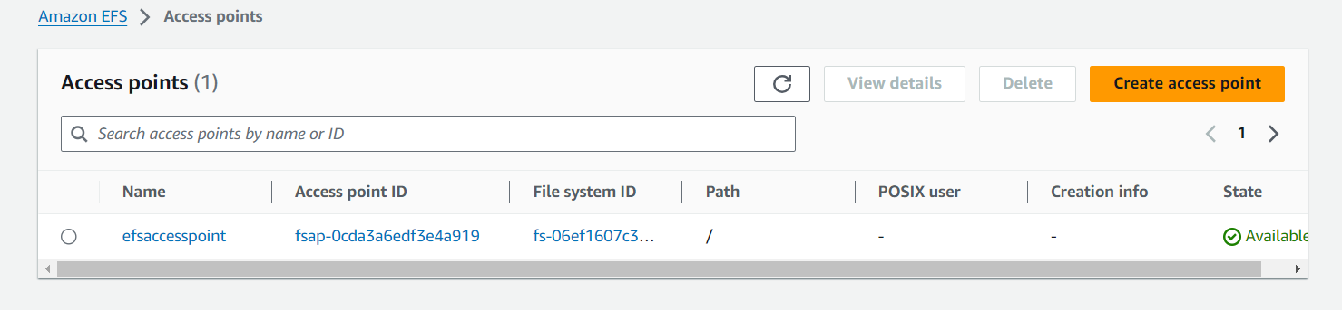

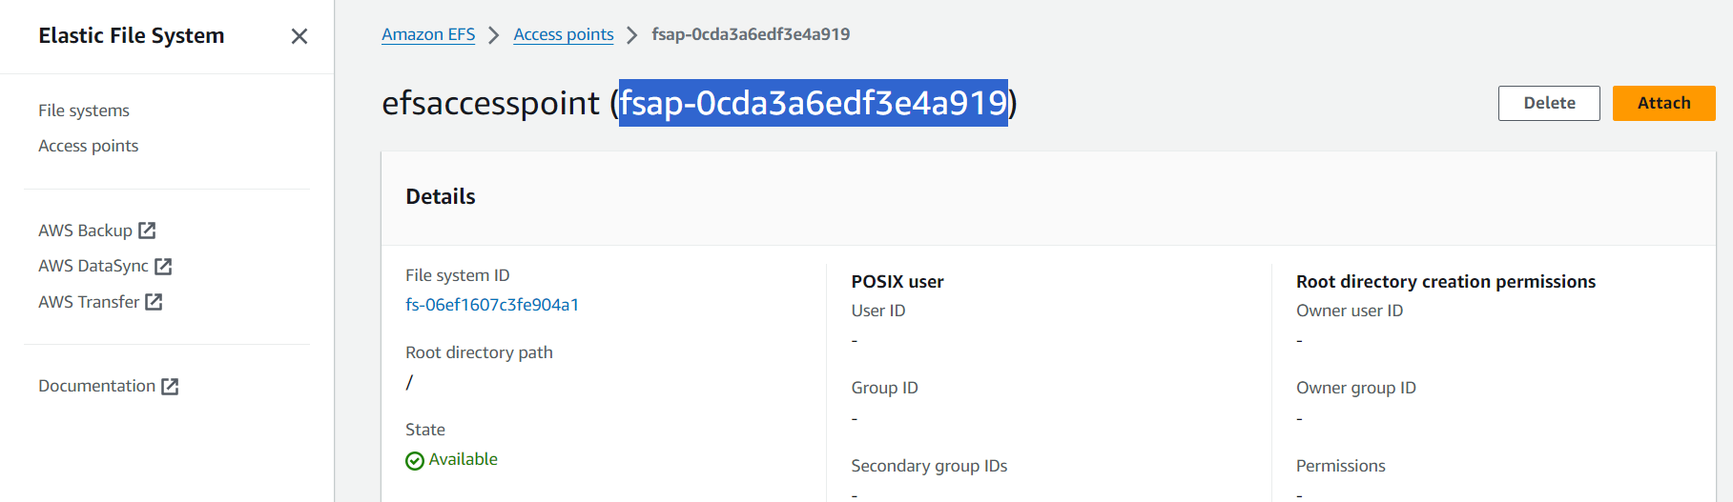



1. **mountpoint: duplicate the tab check the m.p (/home /)**

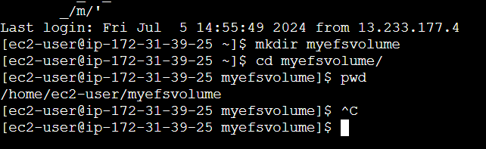

**Remove iam**









**My output file:**







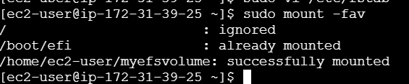

**Df-h cmd used for check the what are all drive attached efs vol mounted in that particular path**



